PHASE 1 BEEE EVALUATION REPORT

AIM : design a system with two buttons such that

1. Red light when pressing any button
2. Green light when pressing both button

CIRCUIT DIAGRAM:

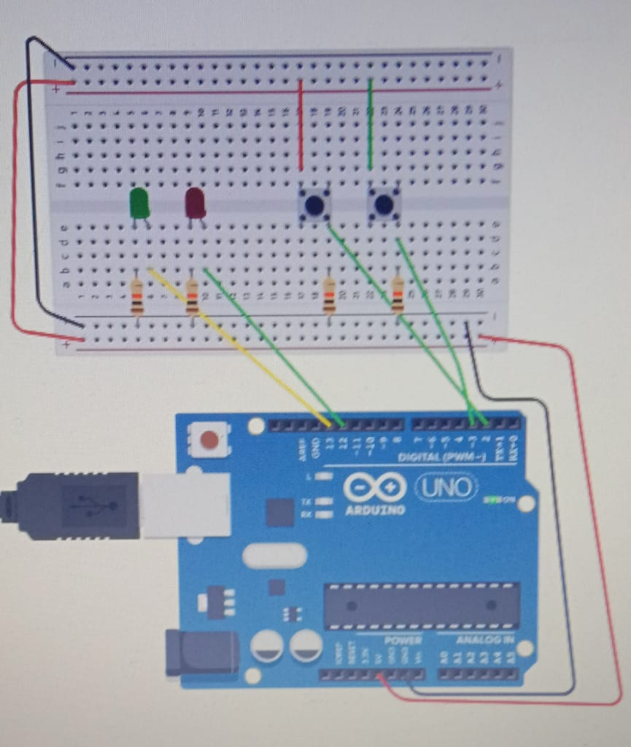

PROGRAM:

int buttonState1=0;

int buttonState2=0;

void setup()

{

pinMode(2, INPUT);

pinMode(3, INPUT);

pinMode(13, OUTPUT);

pinMode(12, OUTPUT);

}

void loop()

{

buttonState1 = digitalRead(2);

buttonState2 = digitalRead(3);

if(buttonState1 == HIGH && buttonState2 == HIGH )

{

digitalWrite(13, HIGH);

}

else

{ digitalWrite(13, LOW);

}

delay(10);

if(buttonState2 == HIGH || buttonState1 == HIGH )

{

digitalWrite(12, HIGH);

}

else

{ digitalWrite(12, LOW);

}

delay(10);

}

THEORY:

The important concept in this experiment is write the conditions using operator && and operator || , this help you to make glow led according to given conditions of buttons.

RESULT:

1. GREEN LED GLOW AFTER PREESING BOTH BUTTONS
2. RED LED GLOW AFTER PREESING ANY ONE BUTTON